**User Manual**

|  |  |  |
| --- | --- | --- |
|  |  | |
| **Made by:** | **CinemaSea**  David Löffler  Marek Szeles | |
| Version: 1.0. | |  |
| Date: 16.5.2016 | |  |

**Contents**

1 Logging into CinemaSea 3

1.1 Registration 3

2 Home panel 4

3 Personalities 5

4 Movies 6

4.1 Rating Movies 7

5 Reload 8

# Logging into CinemaSea

After starting up CinemaSea, you will see a login screen, where you can login after entering your Username and Password by hitting the button “SIGN IN”:

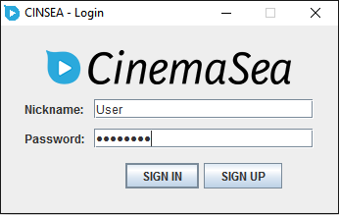

## Registration

If you don’t yet have an account, you can simply register by clicking on the button “SIGN UP” and filling in the necessary information:

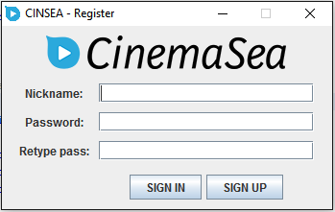

After registration, you will automatically be logged in.

# Home panel

After logging in, you will see the CinemaSea welcome page, the home panel:

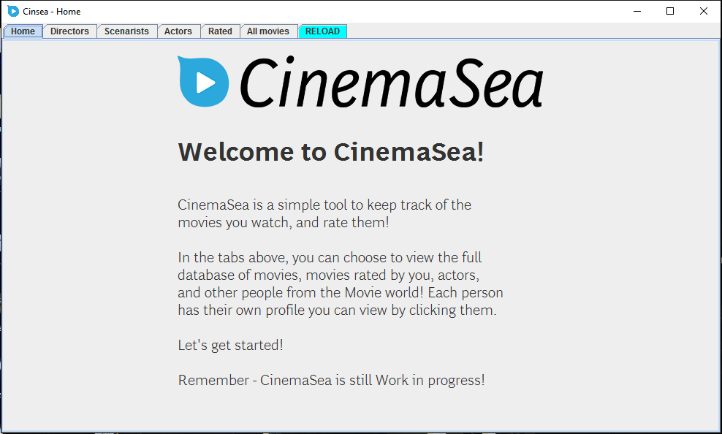

On the top menu, you can pick the different views of the program – different personalities, and movies. There is also a “Reload” panel.

# Personalities

The “Directors”, ”Scenarists” and “Actors” panels represent tables with the different personalities:

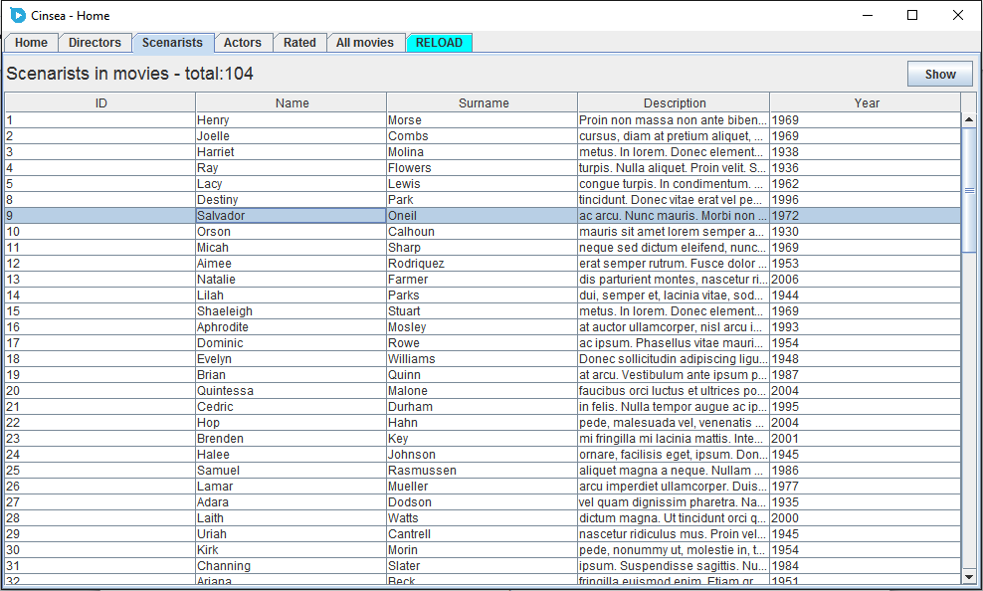

You can view details about the different personalities by selecting their row in the table and clicking on the “Show” button:

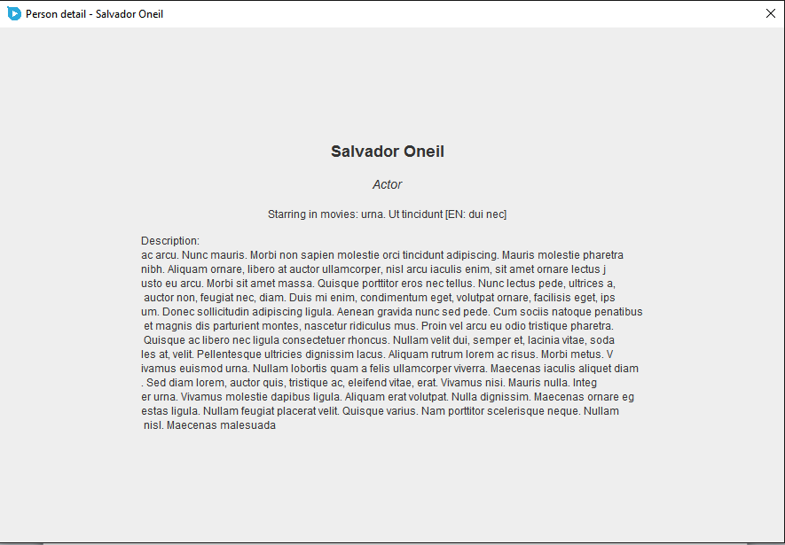

# Movies

In the “All movies” panel you can see all the movies currently in database, and in the “Rated” pane, you can see movies you already rated:

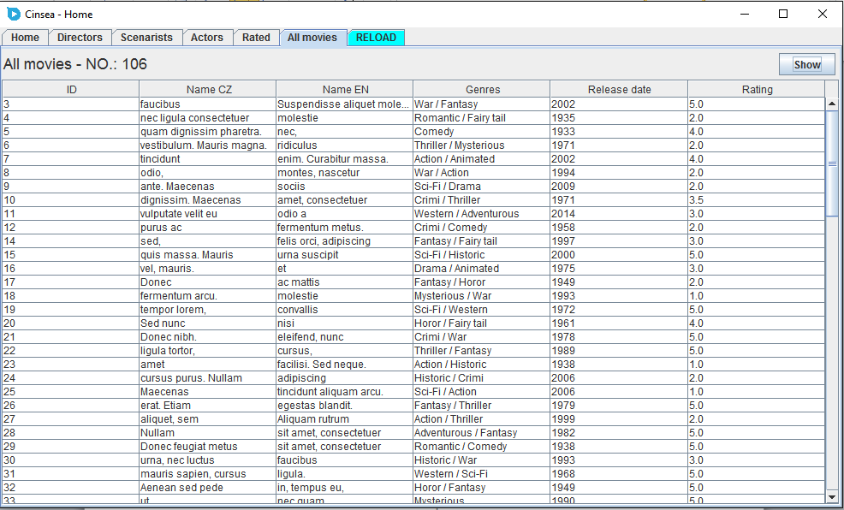

You can view details about the different movies by selecting their row in the table and clicking on the “Show” button:

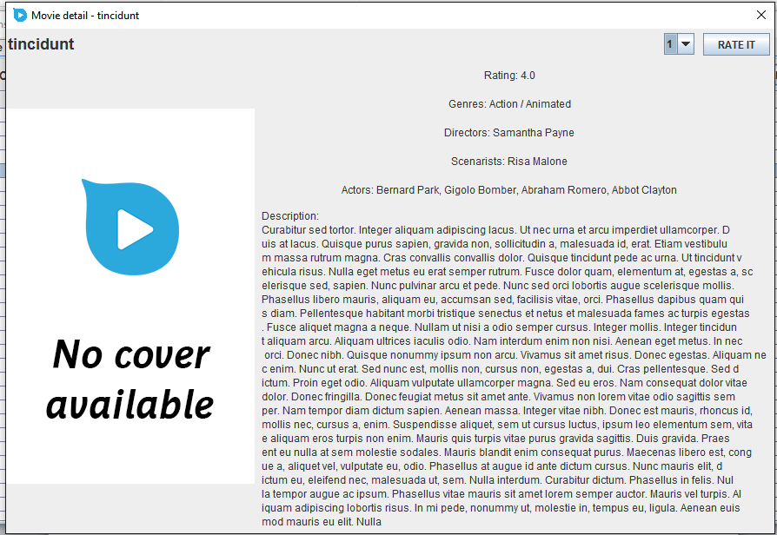

## Rating Movies

In the movie detail screen, you can pass a rating, by selecting a number and pressing “RATE IT” button in the top right corner:

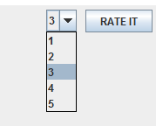

The rating will then be confirmed:

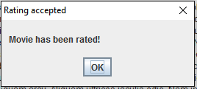

# Reload

If you click the reload pane, you can confirm to re-download the movie database to refresh the movie and personalities tables. You will be prompted to confirm this action:

